FORMULE JAZZY POP
POP / ROCK / SOUL - VERSION ACCOUSTIQUE MI TEMPO
En duo : GUITARE VOIX STOMP / En trio : GUITARE VOIX KIT BATTERIE CAJON
1h = 15 chansons - 2h = 30 chansons - 3h = 45 chansons
TITRES ET ARTISTES | OUI | NON | WHY  NOT
Ain’t no sunshine – Bill Withers
Back to black – Amy Winehouse
Bad boy - Yseult
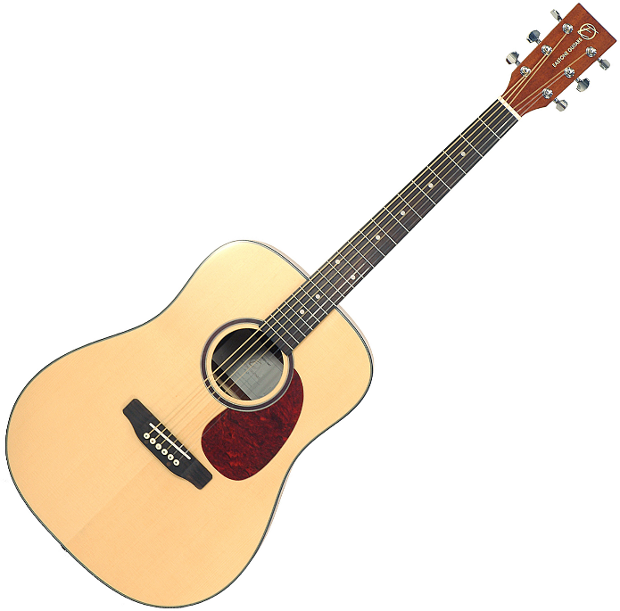
Billie Jean – Michael Jackson
Can’t help fallin’ in love – Elvis Presley
Comment est ta peine – Benjamin Biolay
Corps - Yseult
Crazy -Gnarls barkley
Crazy in love – Beyonce
Don’t Know why – Norah Jones
Everything I do, I do it for you – Bryan Adams
Feeling good – Nina Simone
Fix you - Coldplay
Georgia on my mind – Ray Charles
Get lucky – Daft Punk
How can i do - Anwar
I feel it coming – The weeknd
I Put a spell on you – Annie Lennox
Into the fire – Thirteen Senses
Is This Love – Bob Marley
Isn’t she lovely – Steevie Wonder
Jardin d’hiver – Henri Salvador
La ceinture – Elodie Frégé
La fièvre – Julien Doré
La Liste - Rose
La vie en rose – Edith Piaf
Le coup de soleil – Richard Cocciante
Mad about you - Hooverphonics
Make you feel my love - Adèle
Mercy - Duffy
Mistral Gagnant – Renaud
Moi Lolita – Julien Doré
Mon mec à moi – Patricia Kaas
Nue – Clara Luciani
Photograph – Ed Sheeran
Poison and wine – The Civil Warz
Proud Mary – Tina Turner
Radioactive – Imagine Dragons
Rehab – Amy Winehouse
Saint Claude – Christine and the queens
Seven nation army – The White Stripes
Skyfall - Adèle
Somewhere over the rainbow – Judy Garland
Soulman – Ben l’oncle soul
Stand by me – Ben E.King
Stay with me – Sam Smith
Sweet home chicago – Eric Clapton
Sympathique – Pink Martini
Tout le monde veut devenir un cat – Les Aristochats
Toxic – Britney Spears
True colors - Cindy Lauper
Unintended - Muse
Valerie – Amy Winehouse
Voyage Voyage - Desireless
What a wonderful world – Louis Amstrong
Wicked Game – Chris Isaak
Wild horses – The Sundays
You know I’m no good – Amy Winehouse
